***1C3GH3TT0 – JUKE***

***WRITEUPS***

BrunnerCTF 2025

Categories

Crypto 3

The Cryptographic Kitchen! 3

Encrypted and Desperate 3

Forensics 4

Memory Loss 4

New Order 4

Misc 5

The Yeast Key 5

Pie Recipe 5

Bakerman 5

Cake Constellation 5

Planes! 6

Mobile 7

RivalCakes 7

FridayCake 7

Reverse 8

Trippi Troppa Chaos 8

# Crypto

## The Cryptographic Kitchen!



## Encrypted and Desperate



# Forensics

## Memory Loss

## New Order



# Misc

## The Yeast Key



## Pie Recipe



## Bakerman

## Cake Constellation

After checking all 12:26:3X, I noticed that 12:26:33 was the better viewable, so I changed the script to view only this. after zooming noticed the flag



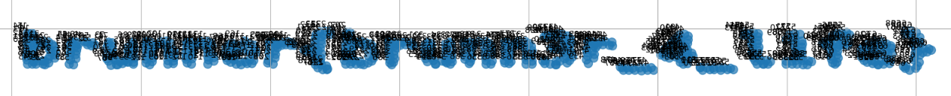

## Planes!

# Mobile

## RivalCakes

After searching in data and sdcard folders, I found the 4 password parts and an image that had some coordinates

<string name="recipe_file">/storage/emulated/0/Download/Cakes/best_cake_in_the_world.jpg</string>

Then opened what3words and input them to complete the flag

## FridayCake

# Reverse

## Trippi Troppa Chaos



